Remote Web Workplace Instructions:
- For Remote Web Workplace (RWW) to work properly, your computer must be left on at the office. For security reasons, lock your computer when you leave by holding down the Windows key (between CTRL and ALT in the lower left hand corner) and pressing the “L” key.
- From any computer outside of the office with an internet connection, navigate to http://mail.hatandsons.com. You should see this window:
- From the window above, choose “Remote Web Workplace”
- Depending on your version of Internet Explorer, you may see a security window pop up telling you there may be a problem with the website’s security certificate. Click on “Continue to this website (not recommended)”
- The next screen is a login screen. Simply use the same username/password you use at the office to login. Leave everything else as is.
- From this screen choose “Connect to Client Desktops”
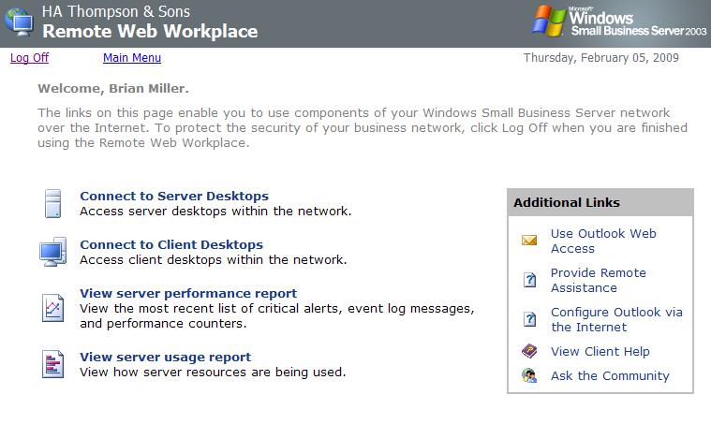

- Again, depending on if you have ever logged in remotely before and/or the version of Internet Explorer you are using, you may see this screen (which you should only see once). Click OK. If you do not see this, skip to item #10.
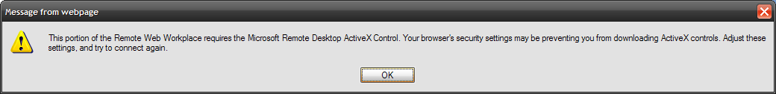
- Look at the top of the screen for a gold bar. Click on it, a drop down menu appears and choose “Run Add-in”. Another menu appears, click “RUN”
- After the Add-in has installed, once again click on “Connect to Client Desktops”
- Select your computer name from the list of computers. Generally speaking it should be listed as your first initial and last name. Then click “Connect”
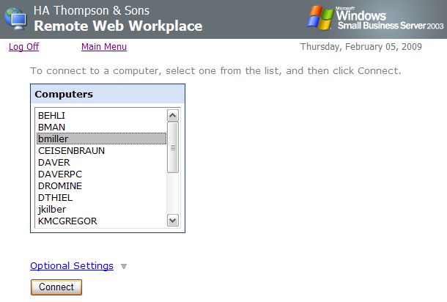

- If this is the first time you have logged in, you will need to confirm this security window. This allows access to your home desktop clipboard (where things magically go when you copy and paste) and your printer if it is supported.
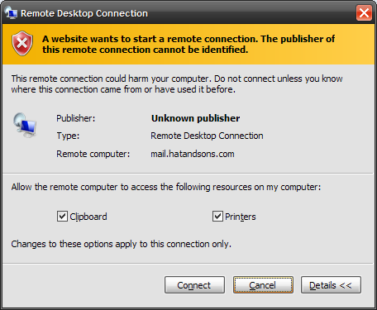
- At this point you should see a standard Windows XP login screen. Use the same username/password you do to log in at the office and you should have access just as if you are sitting in front of your computer at work.
- If you see an additional security pop-up, there are some settings in Internet Explorer that need to be adjusted. If you need help with that, let me know.
- To Log Off, click on Start and then Disconnect or click on the “X” on the file folder tab at the top of the screen:

